 | INVESTMENT DECLARATION FORM FOR THE YEAR 2022-23
Company Name |  | CINNTRA INFOTECH SOLUTIONS (P) LTD.
Employee Code |  | 5816327
Employee Name |  | Ankur Tyagi
Employee PAN |  | AQAPT1569K
Employee DOB |  | 13th Jun 1992
Employee Email & Mobile Number |  | ankur.tyagi@cinntra.in  9990989704 | Gender |  | MALE

I wish to opt old income tax regime and hereby declare that the following investment will be made by me during the financial year 2020-21 starting from 1st of April 2021 to 31st of March 2022 in order to claim exemptions available in the income tax Act , 1961

 |  | Item Name |  |  |  |  |  |  |  | Particulars |  |  |  | Eligibility (Rs.) |  |  | Amount
 |  |  |  | Exemption u/s 10
 |  |  |  | House Rent Allowance |  |  |  |  | I am staying in a Rented
 |  |  |  |  |  |  |  |  | House and I agree to submit
 |  |  |  |  |  |  |  |  | Rent receipts or Rent
 |  |  |  |  |  |  |  |  | Agreement with the |  |  |  | Metro/Non-Metro
Landlord when required.
I will also provide PAN of landlord in case if rent exceed Rs.100000 per annum

 |  |  |  |  |  |  |  |  | Rent Paid
 |  |  |  |  |  |  |  |  | is__8200___x_12___Months |  |  |  |  |  |  | 98,400
 |  |  |  | LTA |  |  |  |  | Proposed travel for LTA |  |  |  |  | Planning to claim LTA this year
 |  |  |  |  |  |  |  |  | Exemption for the
 |  |  |  |  |  |  |  |  | Block 2018-2021
 |  |  |  |  |  |  |  |  | Claims during the year 2018 |  |  |  |  | Yes/No
 |  |  |  |  |  |  |  |  | Claims during the year 2019 |  |  |  |  | Yes/No
 |  |  |  |  |  |  |  |  | Claims during the year 2020 |  |  |  |  | Yes/No
 |  |  |  |  |  |  |  |  | Claims during the year 2021 |  |  |  |  | Yes/No
 |  |  |  |  |  |  |  |  | If I do not produce the bills
 |  |  |  |  |  |  |  |  | to the satisfaction of the
 |  |  |  |  |  |  |  |  | company, then the Company
 |  |  |  |  |  |  |  |  | can consider the amount |  |  |  |  | Yes/No
 |  |  |  |  |  |  |  |  | paid towards LTA for tax
 |  |  |  |  |  |  |  |  | purpose

Deduction u/s 24
 |  | Interest on Housing Loan for maximum two self occupied house property |  |  |  | Maximum limit Rs.200000/-
- Interest can be claimed from the year in which the construction of the property completed
- Provisional Banker/financial institution certificate required along with PAN
 | Deduction u/s 80C (Maximum Amount Up to Rs.150000/-)
1 |  | Life Insurance Premium (LIC)
2 |  | Provident Fund (PF)
3 |  | Public Provident Fund (PPF) |  |  |  | 6225*12 | 74,700
4 |  | Voluntary Provident Fund (VPF)
5 |  | National Savings Certificate (NSC)
6 |  | Interest accrued on NSC(Re-invested)
7 |  | Unit Linked Insurance Policy (ULIP)
8 |  | Equity Linked Savings Scheme (ELSS)-Mutual
 |  | Fund
9 |  | Payment for Tuition Fees for Children (Max. 2 |  |  |  | 1000*12 | 12,000
 |  | Children)
10 |  | Principal Repayment of Housing Loan
11 |  | Stamp Duty, Registration charges incurred for
 |  | Buying House (1st Year Only)
12 |  | Infrastructure Bonds
13 |  | Tax Saving Bank Fixed Deposit For 5 Years & Above
14 |  | Post Office Term Deposit For 5 Years & Above
 | Other deduction u/s 80
 | 80 D | Medical Insurance Premium- |  | (Max. Limit-Rs.25000/- if a
 |  | Individual, Spouse & dependent Children |  | person insured is other than
 |  |  |  | Senior Citizen)
 | 80 D | Medical Insurance Premium-Parents |  | (Max. Limit-Rs.50000/-if any
 |  |  |  | person insured is a Senior
 |  |  |  | Citizen)
 | 80 D | Preventive Health Check-up |  | Max. Rs.5000/- (inclusive in
 |  |  |  | overall limit of
 |  |  |  | Rs.25000/Rs.50000)
 | 80 E | Interest for Loan taken for Higher |  | No Limit (Only Interest
 |  | Education |  | portion)

Others
(Please

Specify)
Income from Previous Employment:
1. | Income (attach Payslips/Salary certificate etc ) |  | ____4 LPA____________
2. | Provident Fund (PF) |  | ______NA____________
3. | Professional Tax (PT) |  | ______NA____________
4. | Tax Deducted at Source (TDS) |  | ______NA____________

Declaration: -

I ___Ankur Tyagi___ hereby declare that the information given above is correct and true in all respects. I also undertake to indemnify the company for any loss/liability may arise in the event of the above information being incorrect.
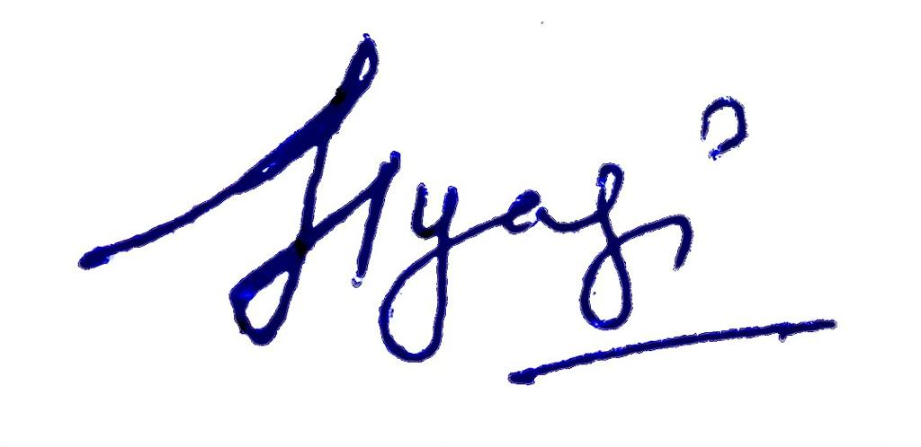

Date: 20th May’22

Place: Noida Signature of the employee

